SYNOPSIS

ON

“INVISIBLE CLOAK”

Submitted in

Partial Fulfillment of requirements for the Award of Degree

*of*

Bachelor of Technology

*In*

Computer Science and Engineering

By

**(Project Id: 2A07)**

# Ayush Kushwaha (1901640100089)

Under the supervision of

**Neha Singh**

**(Assistant Professor)**



**Pranveer Singh Institute of Technology**.

 Kanpur - Agra - Delhi National Highway - 2

Bhauti -Kanpur - 209305.

(Dr. A.P.J. Abdul Kalam Technical University)

**TABLE OF CONTENT**

|  |  |  |
| --- | --- | --- |
| Sr No. | Topic | Page |
| 1 | Introduction | 2 |
| 2 | Project Objective | 3 |
| 3 | Feasibility Study | 4-6 |
| 4 | Methodology/ Planning of work | 7-12 |
| 5 | Facilities required for proposed work | 13 |
| 6 | Reference | 14 |

**Synopsis**

1. Introduction

Here we will make our own Invisible Cloak using OpenCV-python and some basic computer vision techniques.  We likewise going to utilize some fundamental thought of color detection and segmentation to create some magical experience just like Harry Potter does in his movies

It is an Image Processing method and by making segments of a single predefined Colour from the video and replacing it with a pre-existing same background, we can create the invisible cloak.

You must have a cloth of the similar shading and there ought to be no other shading noticeable in that material. Here we are taking the red cloth and if you want you can take some other Colour cloth-like green, blue Colour cloth, etc.

We will be using both the **web-camera and android camera** for the testing of Invisible Cloak

**2. Project Objective**

Have you ever thought of making visible things invisible, just like the Harry Potter? Have you ever thought how does one supersede backgrounds and add effects in a movie? The cloak was magical and invisible in Harry Potter, the movie. As we know there is no magic and no invisible cloak which exists in the world. It’s all about the graphics tricks. The concept of an invisibility cloak is a mixture of science, fantasy, and the collective imagination. This program helps to become Invisible. It will make use of Python and OpenCV module specifically targeting Image Processing and Image Segmentation to create a false sense of invisibility in the frame. It will explore how an object of a specific color or texture can be manipulated using the OpenCV library of python and we will use Tkinter to create a GUI Application so you can use it in a better way. And also, we use NumPy and PIL.

3. Feasibility Study:

Feasibility is the determination of whether or not a project is worth doing. The process followed in making this determination is called a feasibility study. This type of study determines if a project can and should be taken. Once it has been determined that a project is feasible, the analyst can go ahead and prepare the project specification which finalizes project requirements.

**Different Type of Feasibility Study: -**

In the conduct of the feasibility study, the analyst will usually consider seven distinct, but inter- related types of feasibility. They are:

* Technical Feasibility
* Operational Feasibility
* Economic Feasibility
* Social Feasibility
* Management Feasibility
* Legal Feasibility
* Time Feasibility

**(1) Technical Feasibility: ‑**

This is concerned with specifying equipment and software that will successfully satisfy the user requirement; the technical needs of the system may vary considerably, but might include:

The facility to produce outputs in a given time:

• Response time under certain conditions.

• Ability to process a certain volume of transaction at a Particular speed.

• Facility to communicate data to distant location. In examine technical feasibility; configuration of the system is given more importance than the actual makes of hardware. The configuration should give the complete picture about the system’s requirement: How many workstations are required, how these units are interconnected so that they could operate and communicate smoothly. What speeds of input and output should be achieved at particular quality of printing? This can be used as a basis for the tender document.

(**2) Operational Feasibility: -**

It is mainly related to human organization and political aspects. The points to be considered are:

• What changes will be brought with the system?

• What organizational structures are distributed?

• What new skills will be required? Do the existing staff members have these skills? If not, can they be trained in due course of time? Generally project will not be rejected simply because of operational infallibility but such considerations are likely to critically affect the nature and scope of the eventual recommendations.

**(3) Economical Feasibility: -**

Economic analysis is the most frequently used technique for evaluating the effectiveness of a proposed system. More frequently known as cost / benefit analysis; the procedure is to determine the benefits and saving that are expected from a proposed system and compare them with costs. If benefits outweigh costs, a decision is taken to design and implement the system. Otherwise, further justification or alternative in the proposed system will have to be made if it is to have a change of being approved. This is an ongoing effort that improves in accuracy a teach phase of the system life cycle.

**(4) Social Feasibility: -**

Social feasibility is a determination of whether a proposed project will be acceptable to the people or not. This determination typically examines the probability of the project accepted by the group directly affected by the proposed system change.

**(5) Management Feasibility: -**

It is a determination of whether a proposed project will be project or gives a negligible support to it; the acceptable to management. if does not accept a project or gives a negligible support to it.

4. Methodology/ Planning of work

4.1 How It Works

The working is opposite to the concept of green screening. As in the case of green screening background is removed but, in this application, we remove the foreground. Red colored cloth is used as a cloak for this application. We can use any Colour with a little bit of changes in the calibration.

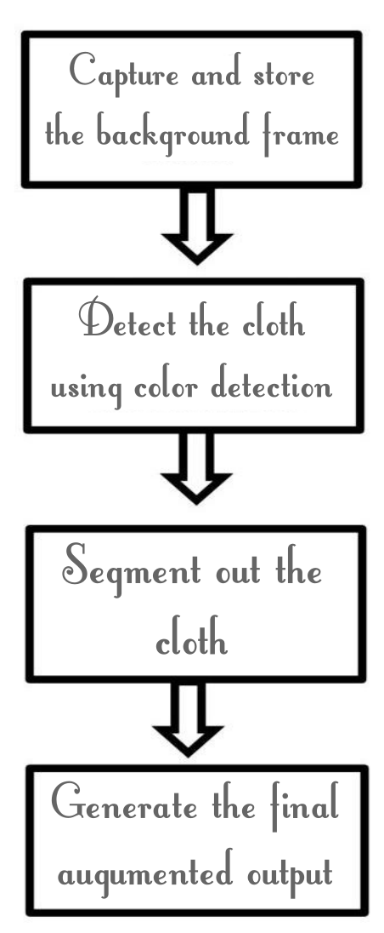

Flow Chart

This fig shows the steps to be followed in order generate the augmented output.

1. Capture and store the background frame

The main concept is interchanging the current frame picture element equivalent to the fabric with the backdrop pixels, so that we obtain the magical effect of invisibility. Thus, we’re required to save a frame of the backdrop.

2. Identify the cloth (cloak) by using the Colour detection & segmentation algorithm

The correct concept is to change the color space of the picture from ‘R.G.B.’ (Red, Green, Blue) value to ‘H.S.V’ (Hue, Saturation, Value).

About ‘H.S.V’ color space

‘Hue’: It gives the information about color.

‘Saturation’: It explains about the intensity of the color.

‘Value’: It tells about the luminosity of color. Shading component of an pictures appears here.

3. Segmenting out the cloak by generating a mask

We refine the mask & then it is further used for segmenting out the fabric from the frame.

4. Generate the final augmented(magical) output to create Invisibility cloak

Finally, we’ll be replacing ‘the pixels value of the detected cloak colored area of the cloth with corresponding pixel value of the background’ & ultimately generating an augmented (magical) output.

4.2 Modules

1. Connection

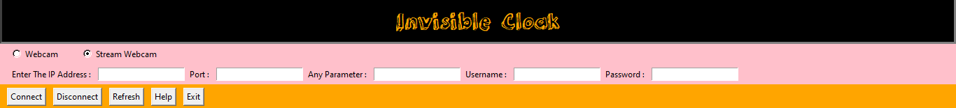There are two options available to connect first is inbuilt webcam or any other external webcam connected to the system and second is the Stream Webcam in which we can connect to online webcams, CCTV and also to smartphones using this option

Stream Webcam Option

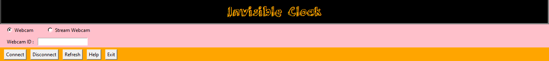

Inbuilt Webcam or Any Connected Webcam Option

2. Change Background

To Capture the background and to save at location “user\videos\invisible cloak”

3. Show Background

To See the captured background, is it clicked right or not

4. Calibration

To set the HSV Values, program can detect the cloak easily.

It Have Six Values named as follow

Upper HUE: Ranges From 0 - 255

Upper Saturation: Ranges From 0 - 180

Upper Value: Ranges From 0 - 180

Lower HUE: Ranges From 0 - 255

Lower Saturation: Ranges From 0 - 180

Lower Value: Ranges From 0 – 180

‘Hue’: It gives the information about color.

‘Saturation’: It explains about the intensity of the color.

‘Value’: It tells about the luminosity of color. Shading component of an pictures appears here.

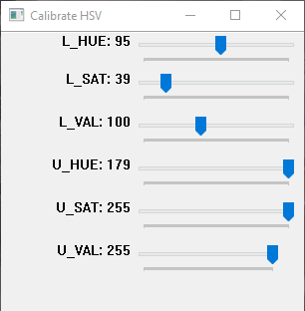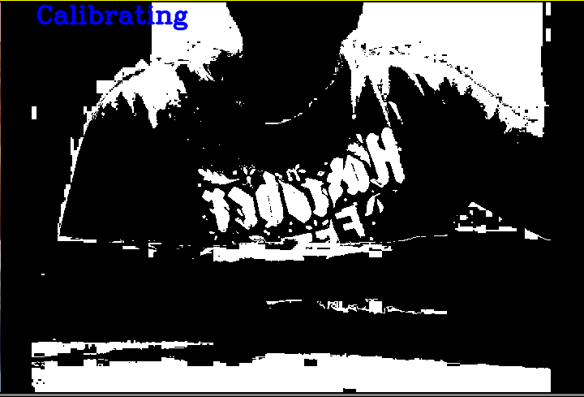

This Is Calibrating Window

Output

5. Start Magic

Finally, detected cloak colored area of the cloth will remove with corresponding pixel value of the background’ & ultimately generating a magical output

6. Recording

You can also record the magical output by checking the check box right beside the start magic option and it will start recording the output and it will be saved at location “user/videos/invisible cloak”

7. Help

This will open the help menu from where user can take help if any problem occurs during the magic

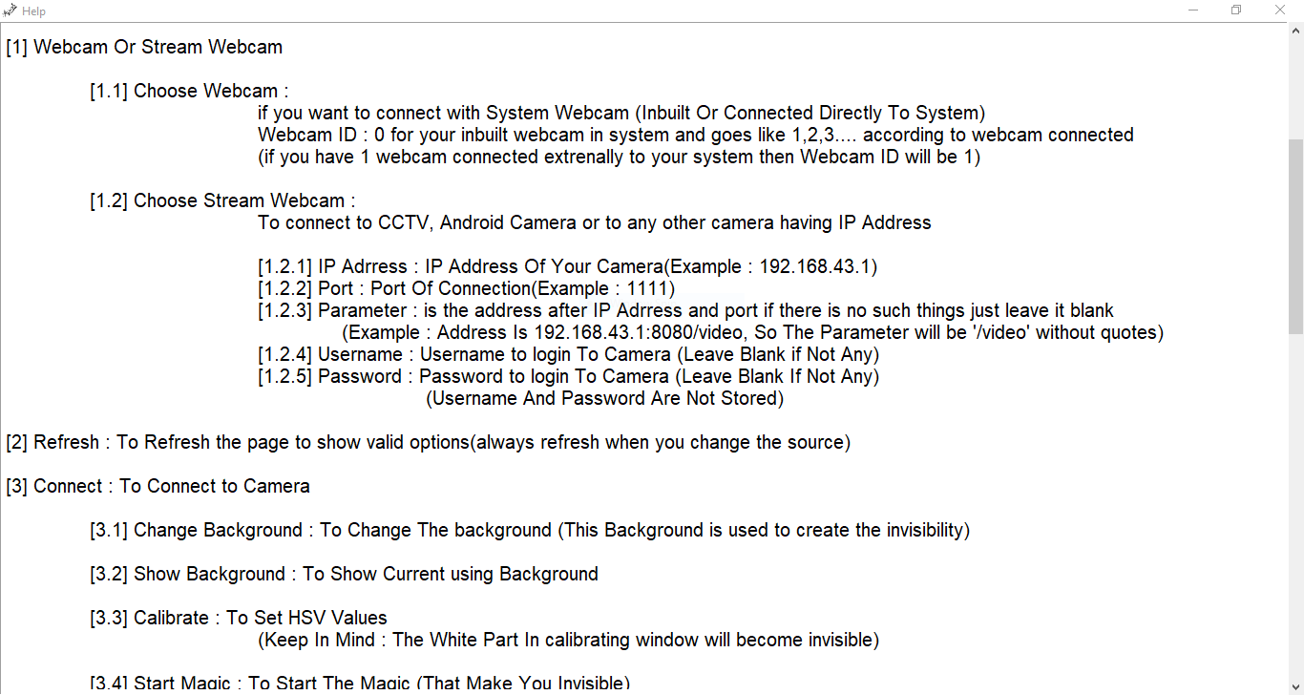

Help Menu

8. Status Bar

It Will show what your program is doing right now



When not connected to any source



When connected to the inbuilt webcam



When connected to the smartphone

5. Facilities required for proposed work

5.1 Hardware Requirements

* + Space Required – 1 GB Free Space
  + Processor – Intel corei3 and above
  + Display – 1366x768
  + RAM – 1 GB
  + Webcam
  + Internet (To Stream Any Other Online Webcam)

5.2 Software Requirements

* Operating System – Windows/Linux/Mac
* Programming language – Python
  + Modules in Python –
  + Open-CV
  + PIL
  + OS
  + Socket
  + NumPy
  + Tkinter
* Any Python IDEs (PyCharm recommended)

6. References

* <https://youtu.be/AkY2TpvDGUo>
* <https://docs.opencv.org/master/>
* <https://docs.python.org/3/library/tk.html>
* <https://tcl.tk/man/tcl8.6/TkCmd/contents.htm>
* <https://www.kite.com/python/answers/how-to-check-if-a-network-port-is-open-in-python>